***Nexus Home – Smart Home Control Web Dashboard***

# **The domain of the Project:**

# G5 - UIUX

# **Team Mentors (and their designation):**

# Sir Sen Ghiri Sudhan

# UI/UX Designer - MetricStream

# **Team Members:**

Ms. Trupti Zaware

# **Period of the project**

# **July 2025 to December 2025**

Declaration

The project titled “Nexus Home – Smart Home Control Web Dashboard” has been mentored by Sir Sen Ghiri Sudhan, organised by SURE Trust, from July 2025 to December 2025, for the benefit of the educated unemployed rural youth for gaining hands-on experience in working on industry relevant projects that would take them closer to the prospective employer. I declare that to the best of my knowledge the members of the team mentioned below, have worked on it successfully and enhanced their practical knowledge in the domain.

Team Members:

Ms. Trupti Zaware

Signature

Mentor’s Name – Sir Sen Ghiri Sudhan

Designation- UI/UX Designer - MetricStream

Prof. Radhakumari

Executive Director & Founder

SURE Trust

Table of contents

1. Executive summary
2. Introduction
3. Project Objectives
4. Methodology & Results(Screenshots)
5. Learning & Reflection
6. Future Scope & Conclusion

***Executive Summary***

Nexus Home is a web-based smart home control dashboard designed to manage multiple devices from a single interface. The project focuses on simplicity, accessibility, and intuitive control.

***Introduction***

Smart home systems often feel complex and overwhelming. Nexus Home aims to simplify device management through a centralized dashboard. This project is conceptual and focuses on experience design rather than real device integration.

***Project Objectives***

* Design an intuitive smart home dashboard
* Simplify device control
* Improve accessibility and clarity

***Methodology and Results***

**Tools Used:**

* Figma
* Notion

**Key Features:**

* Room-wise device management
* Quick controls
* Automation settings

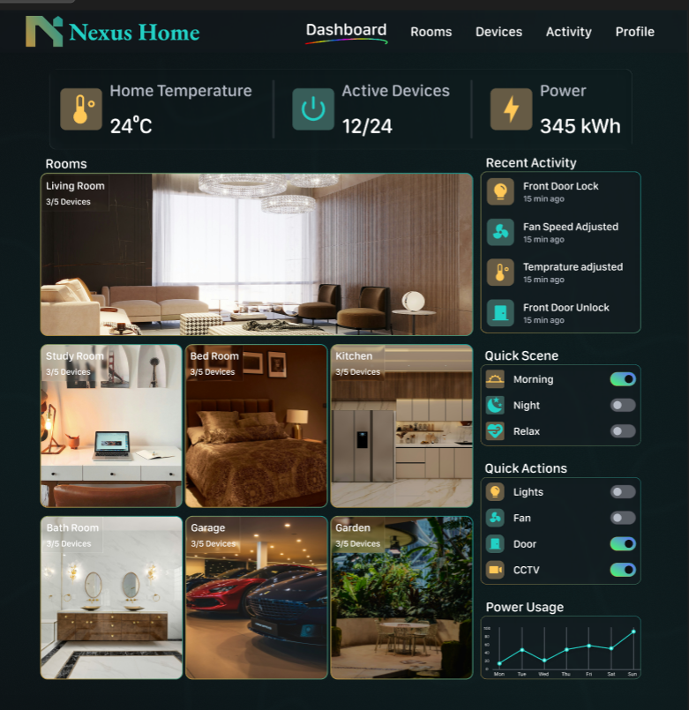

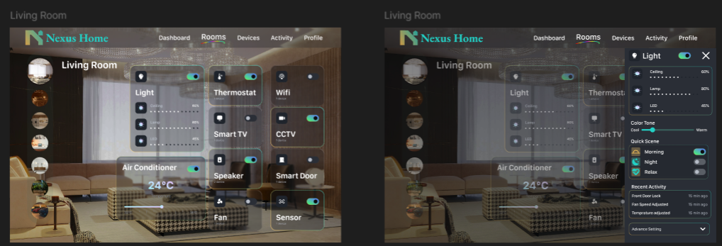

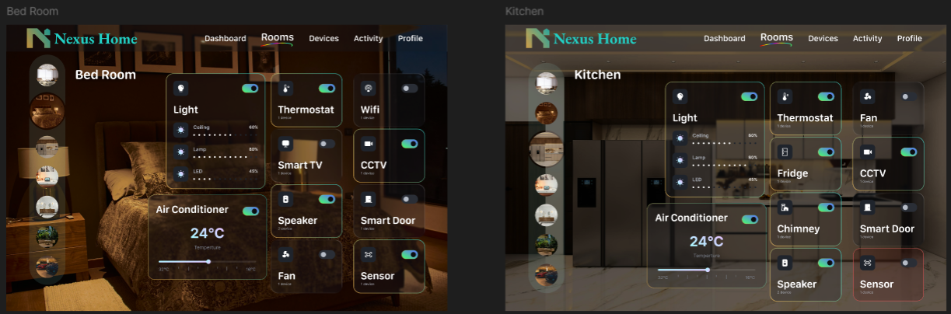

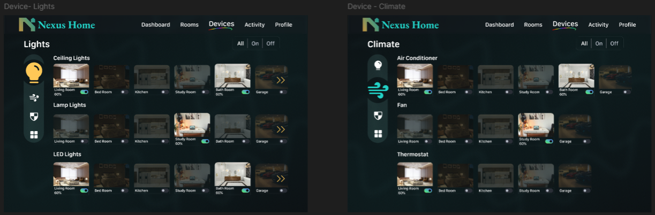

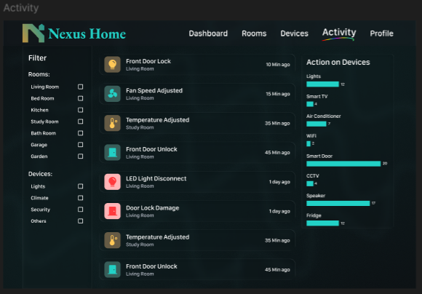

***Learning and Reflection***

I learned how to design complex dashboards while maintaining clarity and ease of use.

***Conclusion and Future Scope***

Future scope includes mobile responsiveness and real device integration.